**ESP2resso Scale – Lunar Eclipse**

**PCB Assembly Guide (v4)**

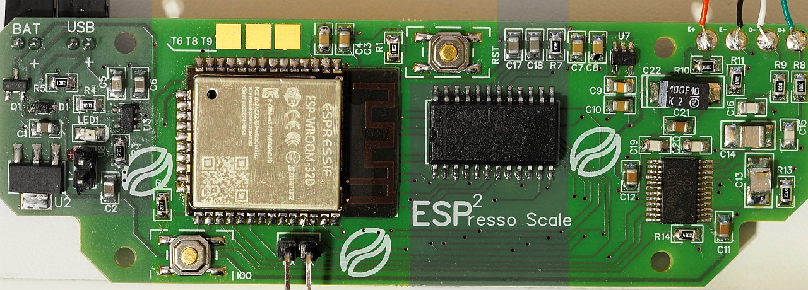

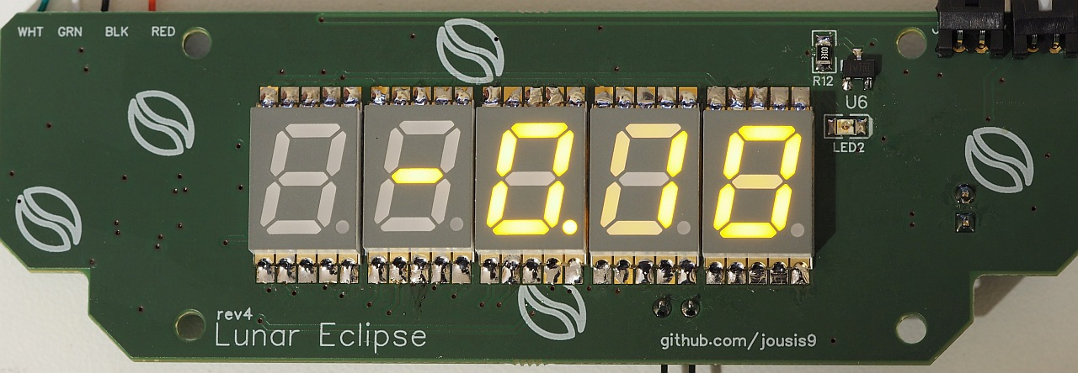

With a little care, you can easily hand solder all the components. No need for hot air.

If you want to minimize the cost, all components except the ADC can be replaced with cheaper alternatives. Try to avoid very cheap components in the analog section (RC filtering) or you might lose some accuracy/stability.

Why “Lunar Eclipse”?  
I liked the name 😊

Why this strange size?   
No specific reason. Rumors say that it is a drop-in replacement for something.

Why “espresso” scale?  
High resolution, high refresh rate needed during an espresso extraction. Apart from that, it is a normal scale.

**Section 1 - Power**

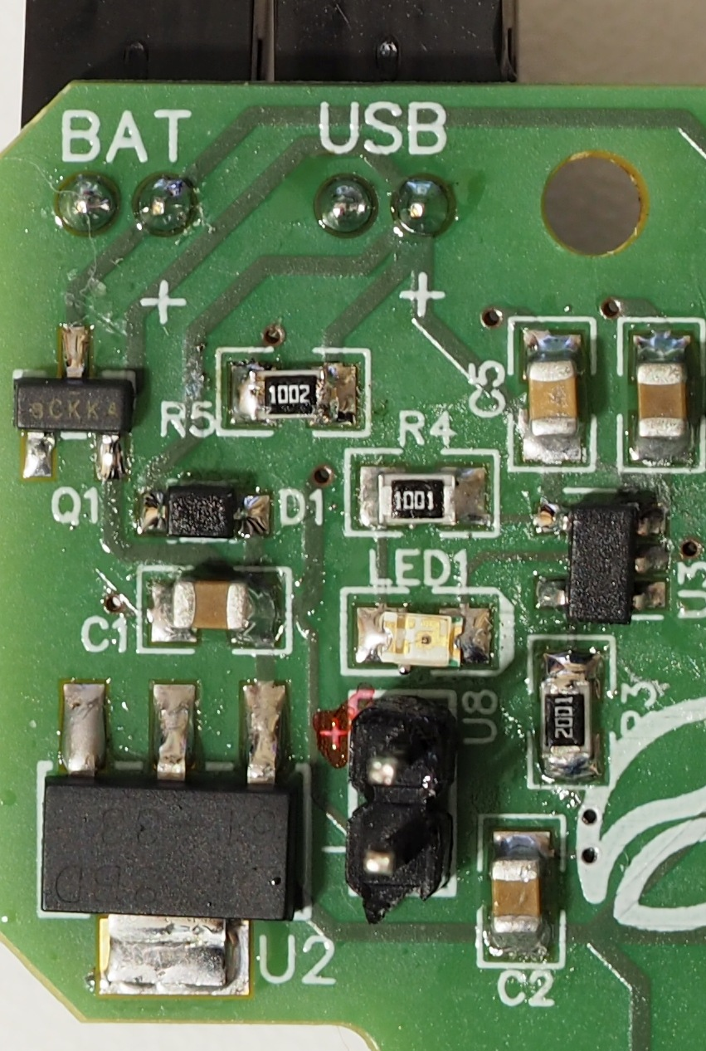

**WARNING: +/- signs on U8 on the photo above are wrong. + is the bottom pin. New PCB has this fixed.**

[Battery charging circuit design: Sparkfun ESP32 Thing](https://cdn.sparkfun.com/assets/learn_tutorials/5/0/7/esp32-thing-schematic.pdf)

If you don’t care about battery / battery charging you can connect DC+5V to U8 and only solder C1, C2 and U2. All other components are for power input management and battery charging.

Please see the schematics for more info.

LDO

I have selected an 1A LDO with relatively low quiescent current, but you can replace it with an even better 500mA if you don’t intend to use Wifi. Remember that, when the esp is in deep sleep mode, the LDO will probably drain more power than the mcu.

Consider also changing package to SOT-23-5. In that case, consider 500mA TLV75533PDBVR.

**Section 2 - MCU**

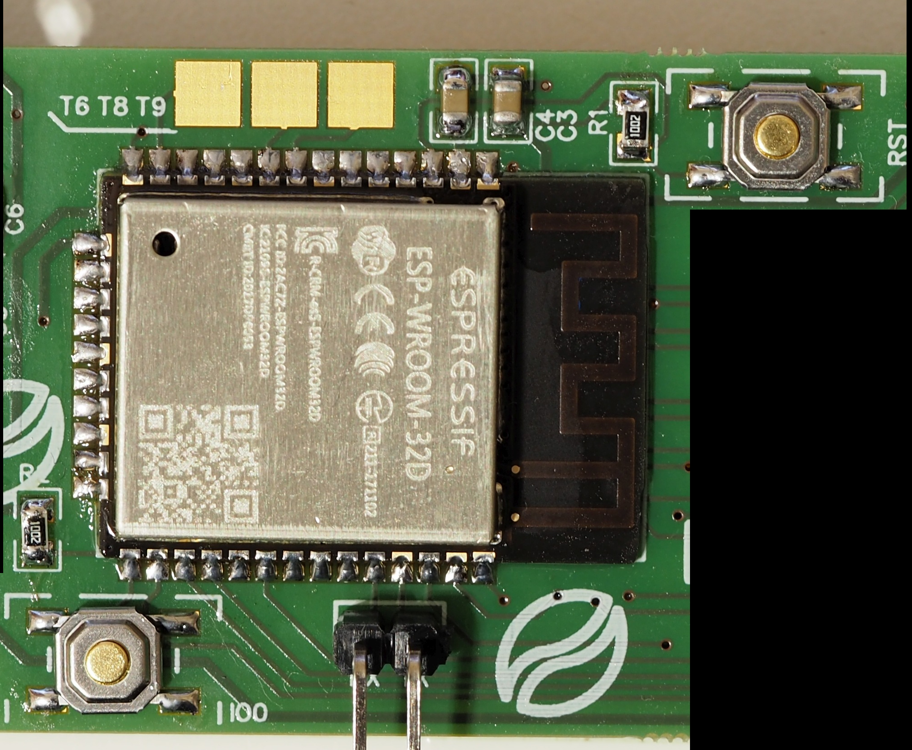

**MCU**

You can use any esp32 wroom with the same footprint (ESP32, ESP32D, ESP32U).

Why module (wroom) and not barebones chip?  
Easier to solder, readily available, reasonable size.

**Programming**

The only way to program your MCU for the 1st time is through the serial connector on the bottom. There is no ftdi chip on the PCB. Afterwards, if you wish, you can setup an OTA method.

**Touch Input**

The exposed 3 solder pads on the top are connected to touch pins T6,T8,T9. Solder a small cable and terminate it in a copper tape behind the plastic case (or any other way you might think of).

**Section 3 - LED Segment Controller**

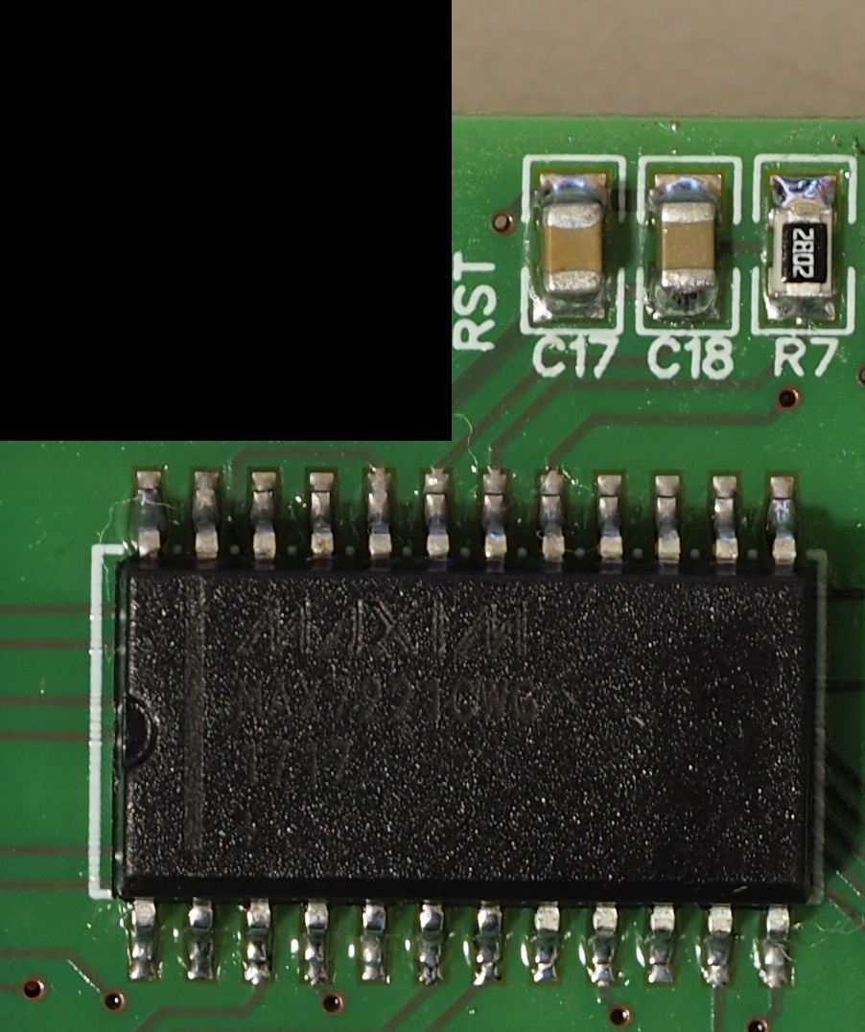

I am using original MAX7221 which costs an arm and a leg, but you can find alternatives much cheaper on ebay. If you don’t care about led segment display, please see the PRO version.

R7 is the resistor that sets the maximum current on the led segments. It depends on the LEDs you use.   
Please read the datasheet for more info or trust me and use 28K.

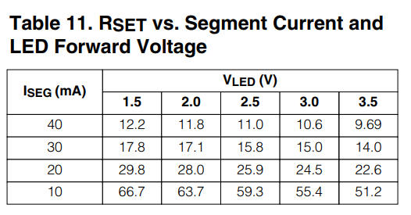

**Section 4 – ADC / Load Cell**

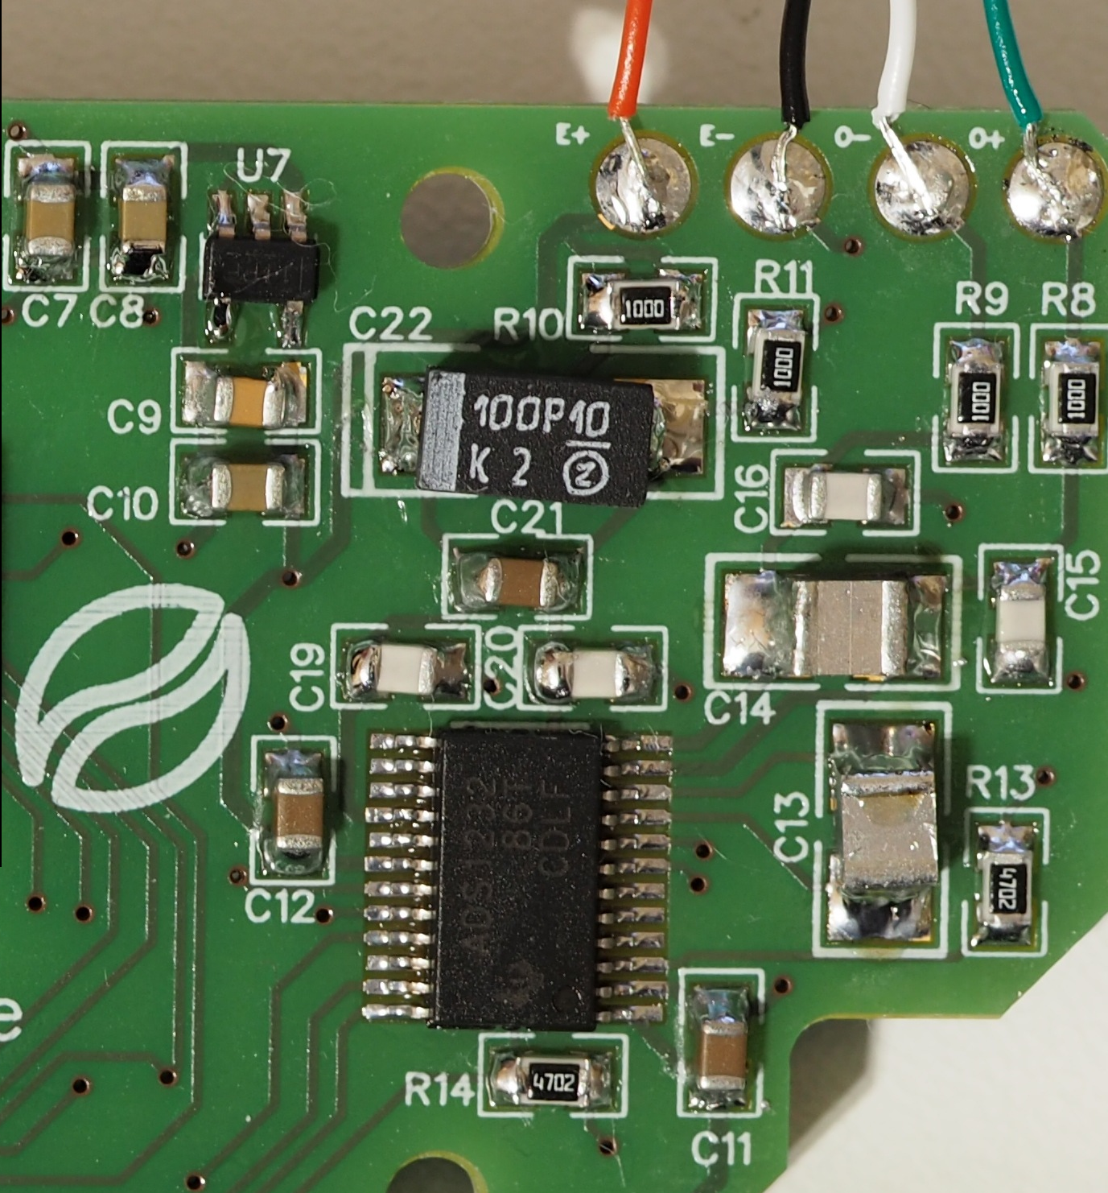

**LDO**

U7 is the local LDO for the analog +3.3V voltage used for the load cell excitation. Use high quality components on everything related to the analog circuit.

The selected LDO has enable pin but in this design is always kept high. During deep sleep, we power down the ADC, but we do cannot control the LDO which stays on. If you want control over the LDO, see the PRO design.

If you choose another LDO, make sure that the output voltage is very stable. Every miniscule variation can lead to false readings or excessive creeping. Also, the higher the voltage, the better the stability/accuracy. If you are designing your own high precision scale that does not need to be battery operated, use 5V.

**ADC**

Compared to the HX711 used in almost all the cheap (and not) designs, ADS1232 from TI is very accurate and stable. Although much more expensive, for this type of scale it is an expense you will have to make. Even when heating it up it could manage 0.1g accuracy (has internal temp sensor). Kudos to TI for their awesome documentation and white papers. (notice: This project is in no way affiliated with TI)

Digital +3.3V comes from the main LDO, analog +3.3V from the local LDO. There is only one ground for both signals (analog/digital) but I tried to avoid any digital signal return path through the analog part of the ADC. Unfortunately, due to the size constraints and the large number of tracks needed for the LED segment controller, digital and analog tracks are relatively close together. That said, I tested the same design with separate analog ground (join under the ADC) and couldn’t find measurable difference.

**Notice: ADS1232 does not communicate using standard SPI. Please see my library.**

**RC filtering**

If you have experience in RC filtering, please redo the calculations and find better values for R/C. I tried my best 😊  
Otherwise, please use high quality caps here or you will lose accuracy and possibly suffer from more creeping than you see on the demo videos.

**Load cell pads**

Some cells have the white/green cables inverted. If you read negative values, swap red/white position.

**Bottom Layer**



Not much to see here.

U6 is a simple voltage supervisor circuit that will light LED2 when LDO output is <2.99 volts*

If you find better low profile LED segments you can use them but check the V and mA they need and change R7 accordingly.

When assembling the final product, remember that you will need semi-transparent film to hide the unlit parts of the display.

When soldering the SMDs, take care, you can easily bridge the pads together. These displays can take a bit of heat, I de-soldered them and re-soldered them 4 times using hot air, no problem apart from some minor browning.

*still testing various batteries and voltage supervisors, if you have any feedback, please share.